Name______________________________________Block____________Date_____________  
MISA- Stellar Evolution

Stars are the building blocks of galaxies. The age, distribution, and composition of the stars in a galaxy trace the history of that galaxy. Stars are responsible for the creation and distribution of elements like carbon, nitrogen, and oxygen, and their characteristics are intimately tied to the characteristics of the planetary systems around them. As a result, the study of the birth, life, and death of stars is central to the field of astronomy.

**The Making Of A Star**

Stars are born within the clouds of dust scattered throughout most galaxies. Disturbances deep within these clouds cause gas and dust to begin to collapse under the cloud's own gravitational attraction. As the cloud collapses, the material at the center begins to heat up. This hot core will one day become a star.

As the cloud collapses, a dense, hot core forms and begins gathering dust and gas. Not all of this material ends up as part of a star. The remaining dust can become planets, asteroids, or comets, or may remain as dust.

A star the size of our sun requires about 50 million years to mature from the beginning of the collapse of the cloud to adulthood. Our sun will stay in this mature phase for approximately 10 billion years.

**The Energy To Shine Bright**

Stars are fueled by the fusion of hydrogen to form helium. Heat and pressure brings about these reactions deep in the interiors of stars. This creates outward pressure, which is necessary to keep the star from collapsing under its own weight. It also creates the energy that makes the star shine.

Stars span a wide range of brightness and color, and they can be classified according to those characteristics. The smallest stars, known as red dwarfs, contain as little as 10 percent of the mass of our sun. Despite their smallness, red dwarfs are by far the most common stars in the universe and have lifespans of tens of billions of years.

On the other hand, the most massive stars, known as hypergiants, may be 100 or more times more massive than the sun. These stars have lifetimes of only a few million years. Although extreme stars such as these are believed to have been common in the early universe, today they are extremely rare.

**The Life Cycle Of Stars**

In general, the larger a star, the shorter its life, although all but the most massive stars live for billions of years. When a star runs out of energy, the core begins to collapse into itself and becomes much hotter. The increasingly hot core pushes the outer layers of the star outward, causing them to expand and cool, transforming the star into a red giant.

What happens next depends on the size of the core.

For average stars like the sun, the process of ejecting its outer layers continues until the core is exposed. This dead but still ferociously hot stellar cinder is called a white dwarf. White dwarfs are roughly the size of our Earth. Billions of years from now, our own sun will be a white dwarf.

White dwarfs are very faint because they are so small. Because they lack a source of energy production, they fade into nothing as they gradually cool down.

This fate awaits only stars up to a certain size, just a bit bigger than our sun. Bigger stars suffer a different fate.

**White Dwarf May Become A Nova**

If a white dwarf forms in a double or multiple star system, it may experience a more eventful end as a nova. Nova is Latin for "new." Nova stars were once thought to be new stars, but today we understand that they are in fact very old white dwarf stars.

If a white dwarf is close enough to a companion star, its gravity may drag matter from the outer layers of that star onto itself, building up its surface layer. Eventually, the added material causes the white dwarf to brighten and then expel the remaining material. Within a few days, the glow subsides and the cycle starts again. Sometimes, particularly large white dwarfs may build up so much mass this way that they collapse and explode completely, becoming what is known as a supernova.

The biggest stars die in a huge explosion called a supernova. In a nova, only the star's surface explodes. In a supernova, the star's entire core collapses and then explodes. In just a matter of seconds, the core shrinks from roughly 5,000 miles across to just 12 miles across, and the temperature spikes 100 billion degrees or more. The outer layers of the star initially begin to collapse along with the core. Then, with the enormous release of energy from the center, they are thrown violently outward.

**Supernova Explosions**

On average, a supernova explosion occurs about once every hundred years in a typical galaxy. About 25 to 50 supernova explosions are discovered each year in other galaxies. Most are too far away to be seen without a telescope.

If a supernova is just the right size, the collapse produces a neutron star. Neutron stars are incredibly dense. Because they contain so much mass packed into such a small size, the gravity at the surface of a neutron star is unimaginably strong.

**The Black Hole**

If a supernova is big enough, it collapses completely to form a black hole, the universe's densest object. The gravity of a black hole is so strong that nothing nearby can escape, not even light. That is why black holes we cannot see black holes. They can only be detected indirectly. Indirect observations are possible because the gravity of a black hole is so powerful that any nearby material is caught up and dragged in. As matter spirals into a black hole, it forms a disk that is heated to enormous temperatures. We can detect the high quantities of radiation released by this disk.

The material left behind by these stars eventually blends with the surrounding gas and dust. It enriches the surrounding materials with the heavy elements that are produced when a star dies. Eventually, those materials become the building blocks for a new generation of stars and planetary systems.

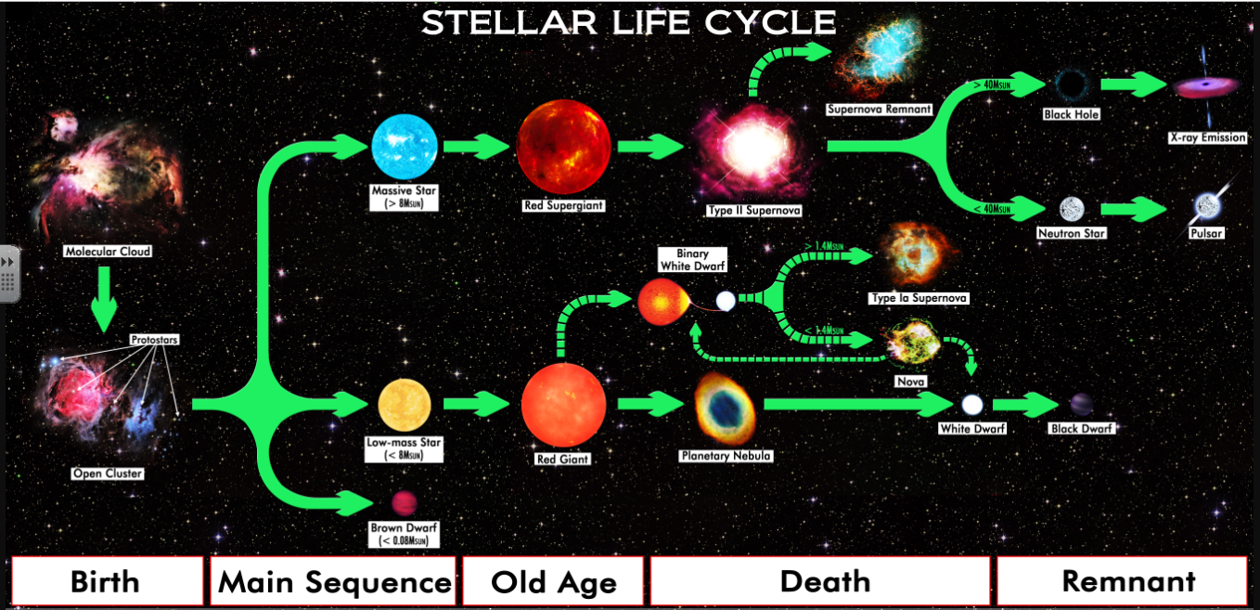By R.N. Bailey - Own work, CC BY 4.0, https://commons.wikimedia.org/w/index.php?curid=59672008

**Using the text, choose the correct answer.**

1. **Which sentence from the article BEST describes the death of a star?**

(A) When a star runs out of energy, the core begins to collapse into itself and becomes much hotter.

(B) As the cloud collapses, a dense, hot core forms and begins gathering dust and gas.

(C) For average stars like the sun, the process of ejecting its outer layers continues until the core is exposed.

(D) Heat and pressure brings about these reactions deep in the interiors of stars.

**2. Which section of the article BEST explains how stars influence one another?**   
  
(A) "The Making Of A Star"   
(B) "The Energy To Shine Bright"   
(C) "The Life Cycle Of Stars"   
(D) "White Dwarf May Become A Nova"

**3. Which answer choice describes two MAIN ideas in the article?**   
  
(A) The characteristics of a star reveal important information about its birth, life and death. The life cycle of a star plays a major role in the evolution of space.   
(B) The size and brightness of a star determines how long and it will shine. The study of stars can help astronomers make predictions about their planetary systems.   
(C) Stars require millions of years to mature and collapse. Dead stars are recycled and blend with surrounding gas and dust to create new planetary systems.   
(D) Stars are classified according to their brightness and color. Larger stars that were common in the early universe are extremely rare today.

**4. Which of the following sentences from the article would be MOST important to include in a summary?**   
  
(A) Stars span a wide range of brightness and color, and they can be classified according to those characteristics.  
(B) Stars are born within the clouds of dust scattered throughout most galaxies.   
(C) Billions of years from now, our own sun will be a white dwarf.   
(D) The material left behind by these stars eventually blends with the surrounding gas and dust

**Writing Prompt**

**5. In a well-written paragraph, explain the life cycle of our sun. Include textual evidence to support the different stages the sun will go through. Use proper grammar, spelling, and punctuation.**

**______________________________________________________________________________________________________________________________________________________________________________________________________________________________________________________________________________________________________________________________________________________________________________________________________________________________________________________________________________________________________________________________________________________________________________________________________________________________________________________________________________________________________________________________________________________________________________________________________________________________________________________________________________________________________________________________________________________________________________________________________________________________________________________________________________________________________________________________________________________________________________________________________________________________________________________________________________________________________________________________________________________________________________________________________­______________________________________________________________________________________________________________________________________________________________________________________________________________________________________________________________________________**

**6.In a well-written paragraph, explain what happens to white dwarf stars that have a companion star (a binary system). Use proper grammar, spelling, and punctuation.**

**______________________________________________________________________________________________________________________________________________________________________________________________________________________________________________________________________________________________________________________________________________________________________________________________________________________________________________________________________________________________________________________________________________________________________________________________________________________________________________________  
________________________________________________________________________________________________________________________________________________________________________________________________________________________________________________________________________________________________________________________________________________________________________________________________________________________________________________________________________________________________________________________________________________________________________________________________________________________________________________________________________________________________________________________________________________________________________________________________________________________________________________________________________________________________________________________________________________________________________________________________________________________________________________________________________________________________________________________**